**Property listing analysis query for property rental company (ROME)**

a. Analyse different metrics to draw the distinction between the different types of property along with their price listings(bucketize them within 3-4 categories basis your understanding):

To achieve this, you can use the following metrics and explore a few yourself as well.

In this we have calculated average price for the different rooms

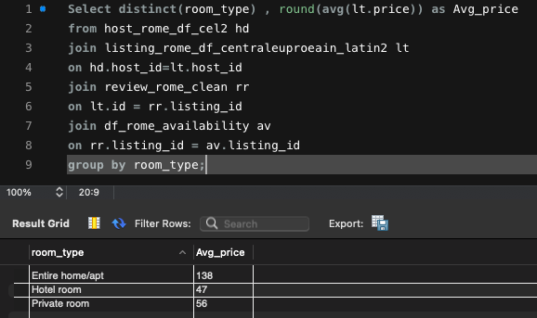

b. Study the trends of the different categories and provide insights on same

- Review score for the different room type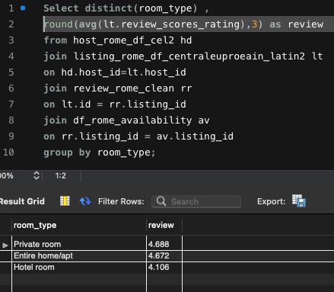

-Cleanliness for different type of the rooms

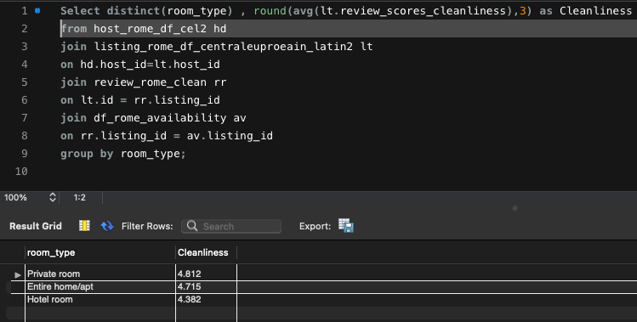

* Instant bookable status for different type of rooms

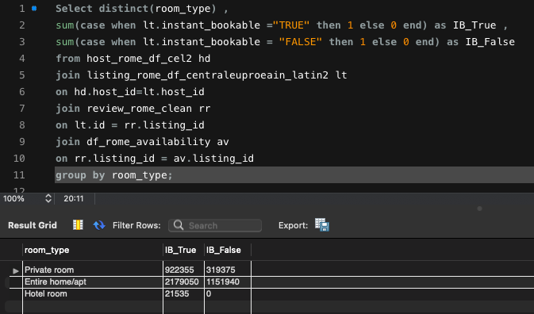

-Communication status in different room type

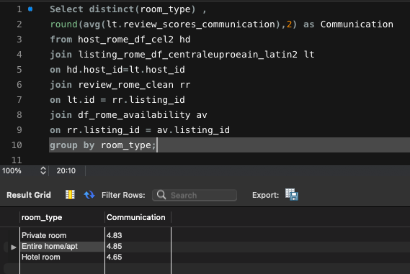

* Discount on private rooms

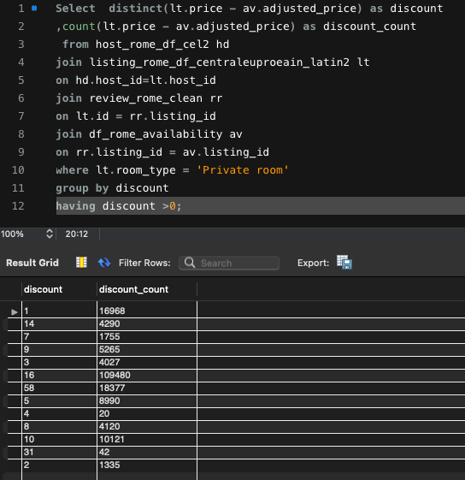

* Discount on 'Entire home/apt'

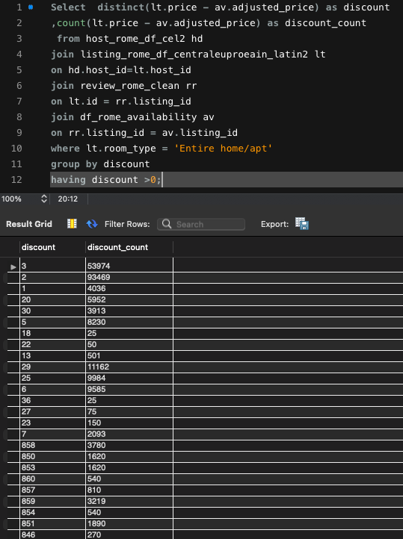

-Discount on hotel room

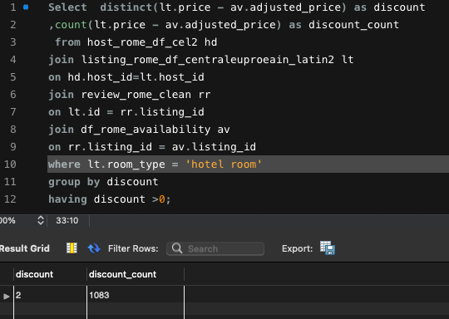

c. Using the above analysis, identify top 2 crucial metrics which makes different property types along their listing price stand ahead of other categories

- The instant bookable metrics and the cleanliness metrics stands ahead the other categories

d. Analyse how does the comments of reviewers vary for listings of distinct categories(Extract words from the comments provided by the reviewers)

-Positive reviews

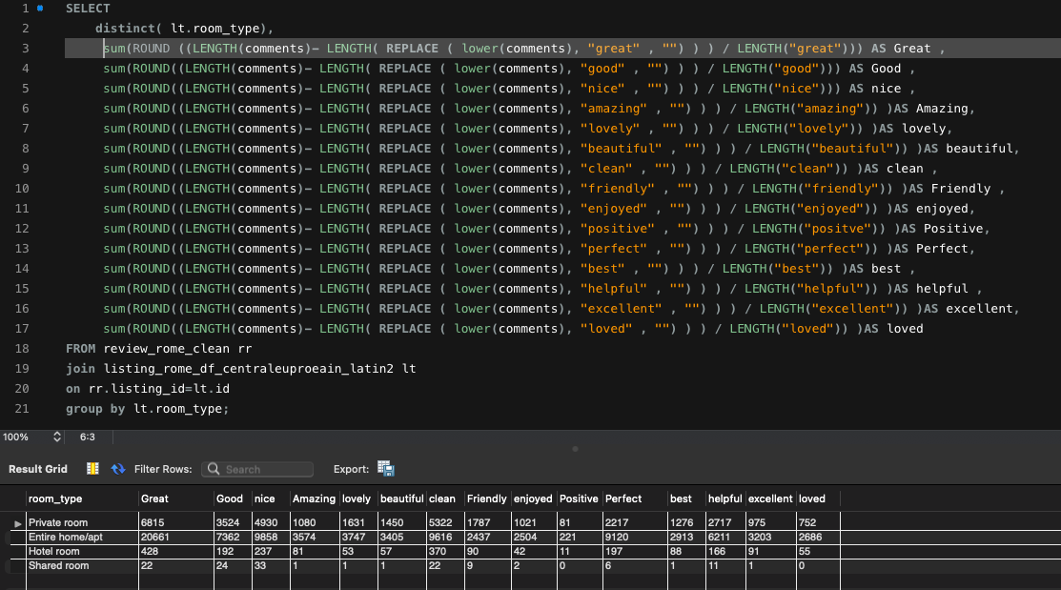

-Negative reviews

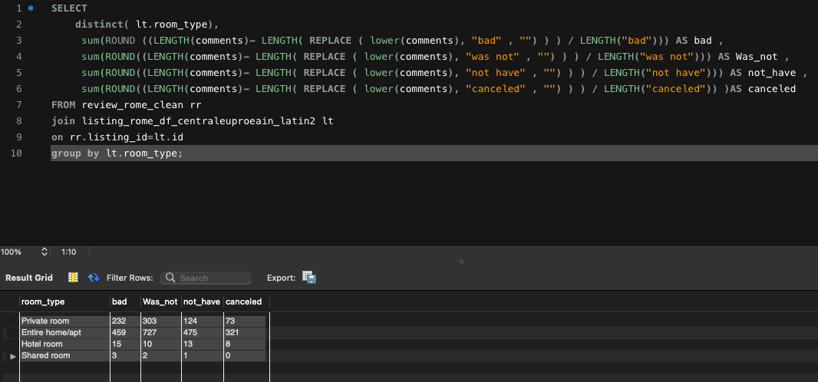

e. Analyse if there is any correlation between property type and their availability across the months

Availability of the Private room

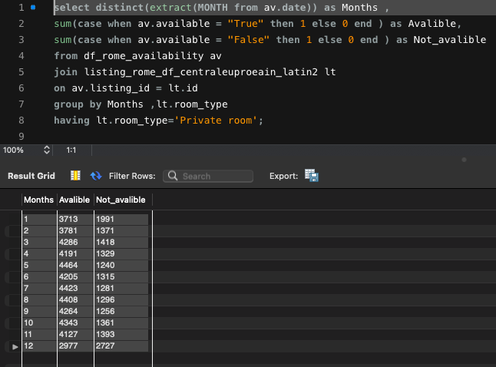

Availability of the Entire home/apt

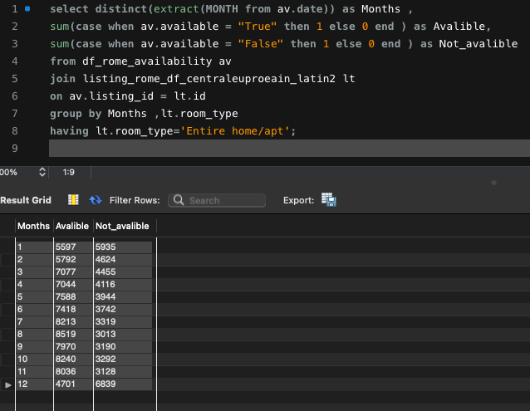

-Availability of the hotel room

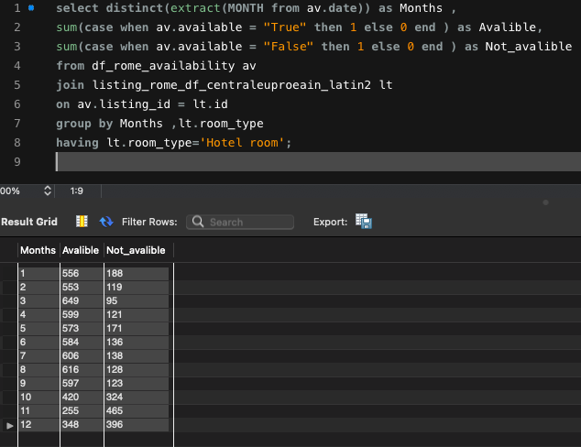

Correlation metrics for months and availability

|  |  |  |  |
| --- | --- | --- | --- |
|  | *Months* | *Available* | *Not_avalible* |
| Months | 1 |  |  |
| Availability | -0.4458544 | 1 |  |
| Not_avalible | 0.51767798 | -0.8973337 | 1 |

There is a negative correlation between months and availability and there is a positive correlation between months and not availability .

f. Analyse what are the peak and off-peak time for the different categories of property type and their listings. Do we see some commonalities in the trend or is it dependent on the category

From the above charts :- There are similar trend for the 12th month in the all three room type. The availability of the room is less in this month and non_avalibility is high . So the Rush in the rooms is high

For the hotel rooms the availability decrease from 9th month but the other two shows the same trend for the overall

g. Using the above analysis, suggest what is the best performing category for the company

-From the above analysis the Private room would be a good choice for the company